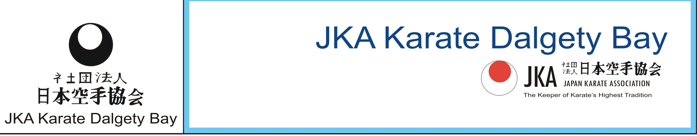
Club Sponsored Kata
Saturday 14th April 2018
11:15-12:30

To raise funds for the Dalgety Bay JKA Scotland squad selected to compete in the JKA European Championships in Serbia.
All grades, all ages welcome, Home baking sale (donations of baking welcome!)
The person with the most money raised wins an Easter Egg!!
Please return your form and sponsor money on the day.
NAME………………………………………… TOTAL RAISED……………………………………………..

Name | Address | Amount | Paid

